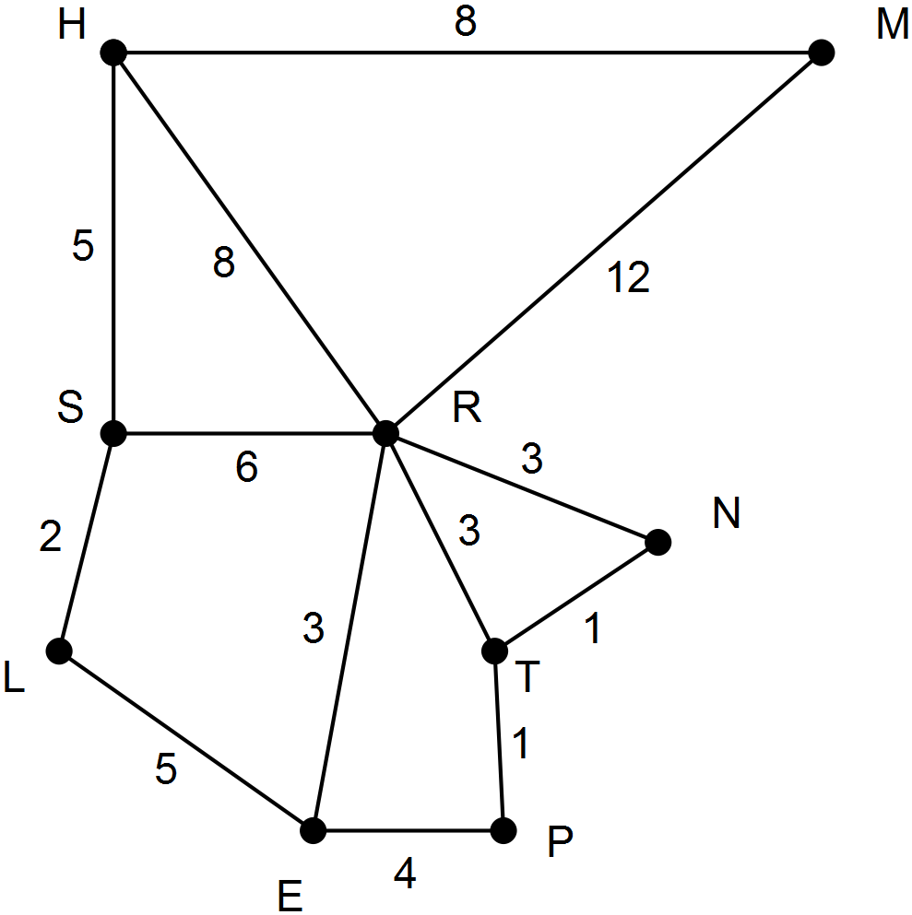

#### Student Name:\_\_\_\_\_\_\_\_\_\_\_\_\_\_\_\_\_\_\_\_\_\_\_

|  |  |
| --- | --- |
| EGC_Black | **Eastern Goldfields College** Mathematics Applications U3&4 2016 Investigation 2 Validation |
| Working Time: 50 minutes | **1xA4 notes page, Calculator Assumed** Total Marks:50 |

# NETWORKS - ROADS

The network below shows a newly developed ring road alignment. Only the major roads are shown and the letters mark the intersections of these roads. The distances have been estimated to the nearest kilometre.



**Question 1 [16 marks: 1, 1, 2, 5, 2, 3, 2]**

Rob wants native plants to be established at each intersection and they will need regular watering during their first summer. For this question the distance travelled by the watering truck is considered.

(a) Starting at R, then going to T then N determine a route for the truck. [1]

(b) Determine the length of the route described in part (a). [1]

(c) Is the route you have described Hamiltonian in nature? Explain [2]

(d) Determine four different watering routes. Each route is to start at a different intersection, finish at the starting intersection and visit every other intersection just once. Determine the length of each route and enter your results in the table provided. [5]

|  |  |  |  |
| --- | --- | --- | --- |
| **Route** | **Starting intersection** | **Route – order of roads travelled** | **Distance** |
| 1 |  |  |  |
| 2 |  |  |  |
| 3 |  |  |  |
| 4 |  |  |  |

(e) Which roads should the driver not use when making a watering route which begins and ends at the same intersection and in which each intersection is visited just once? [2]

(f) Anna decides it is not necessary for the watering truck to return to its starting position but still wants the plants at each intersection watered. Identify three routes of different lengths. State the length of each route. [3]

(g) When the price of petrol is high, which of your three routes in part (f) would be the most economical to use. Justify your answer. [2]

**Question 2 [8 marks: 1, 7]**

The question refers to the same ring road described in the previous question. The diagram is reproduced below.



Mike normally goes for a run before work, running along the road from T to H.

(a) Determine the minimum distance that he would be running. [1]

(b) One particular day the road from T to R was closed. Assuming Mike does not run through any intersection more than once but still begins at T determine

(i) five other running routes [5]

(ii) the difference between the shortest and the longest possible routes. [2]

**Question 3 [13 marks: 1, 2, 2, 2, 4, 2]**

The ring road from the earlier questions is also used here. It is reproduced below.



**End of questions**

Sue will be organising a local marathon and she wants every road included just once and it does not matter where the marathon starts. However, her mathematics students have told her that it will not be possible.

(a) What is the term used to describe to a graph for which it is possible to travel on every connection just the once? [1]

(b) Start at M, go to H. Describe why it is impossible to achieve Sue’s plan. [2]

(c) What features of the network would enable Sue’s mathematics students to identify that the plan was impossible without having to try every route in the network? [2]

By making extra roads it would be possible for Sue to achieve her plan.

(d) Which roads could be made? [2]

(e) Using the new roads, name two possible routes for the marathon. [4]

(f) Assuming any new roads were the same length, which of your marathon routes would be the shortest? Explain. [2]

**Question 4 [13 marks: 2, 1, 4, 3, 3]**



Sue’s mathematics students were asked to describe the network. Ben said it was a simple graph and Sarah said it was planar.

(a) Describe two ways by which roads could be added so that the network is no longer simple. [2]

(b) What did Sarah mean when she said the graph was planar? [1]

(c) Show how you could use Euler’s formula to confirm Sarah’s description. [4]

(d) Redraw the network above so that it is no longer planar. [3]

(e) If such a road network was built so that it was not planar

(i) identify one feature relating to the network structure it could have [1]

(ii) identify an advantage of such a road system [1]

(iii) identify a limitation of such a road system [1]